S3 TASKS

Create an S3 bucket and upload some objects to S3.

Go to aws console
Go to s3 services
Create bucketbucket name should be unique

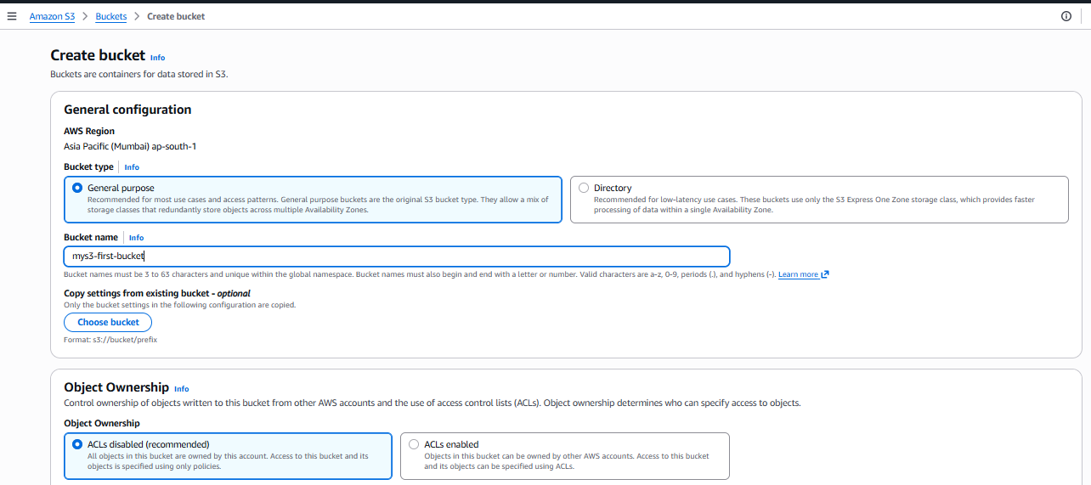
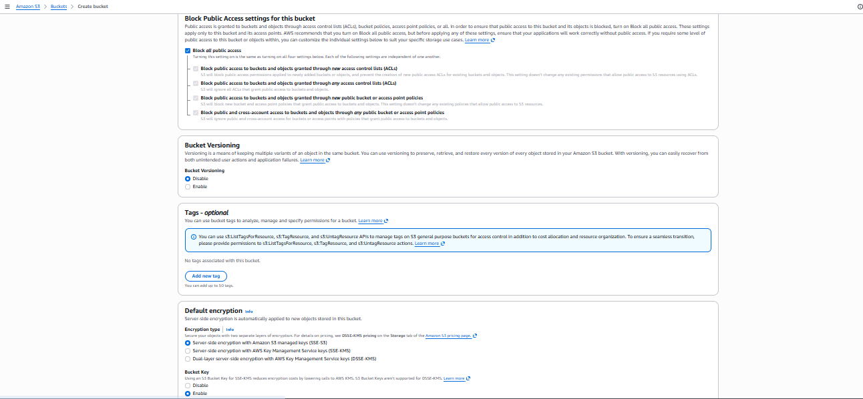

S3 bucket created.
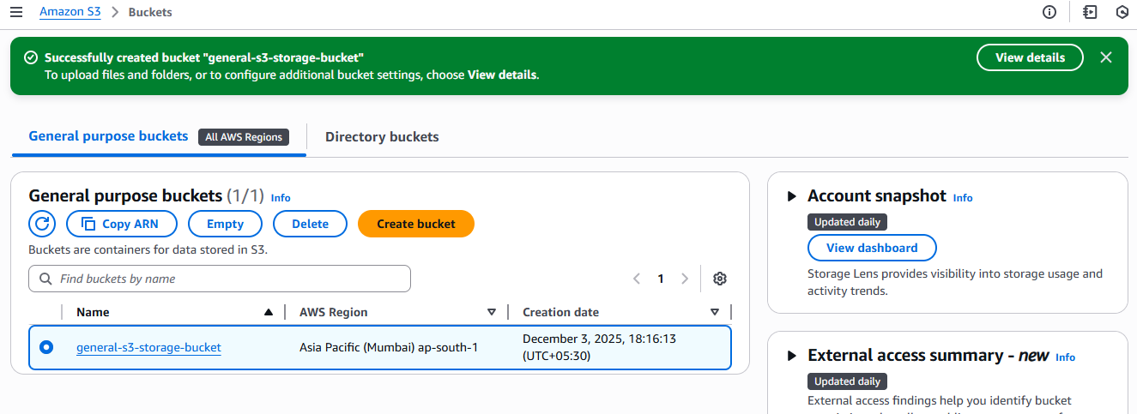

Upload objects to the created s3 bucket.
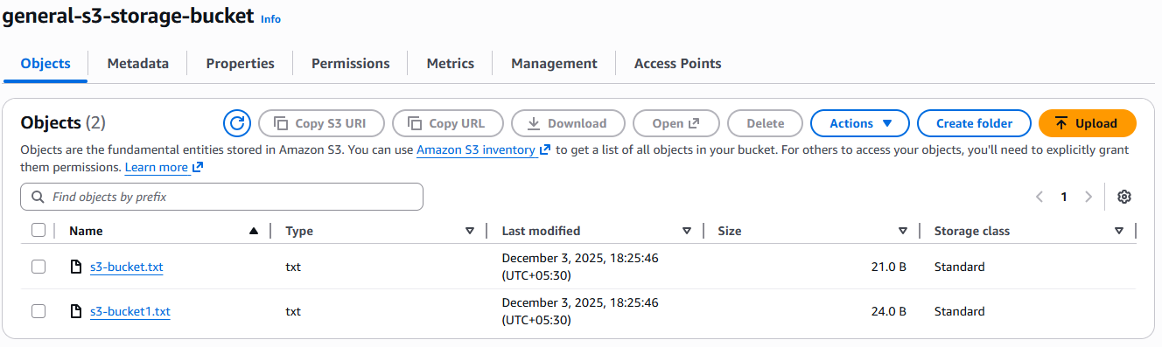

Block Public Access settings for this bucket, uncheck Block all public access to allow public access to your website content.

Go to objects and select public using ACL.
Check the uploaded object in browser.
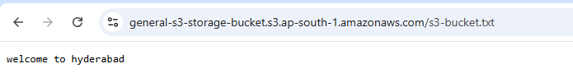
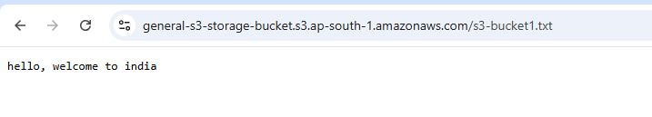
Deploy a static website in the S3 bucket.

Create a s3 bucket
Under Block Public Access settings for this bucket, uncheck Block all public access to allow public access to your website content.
Review and create the bucket

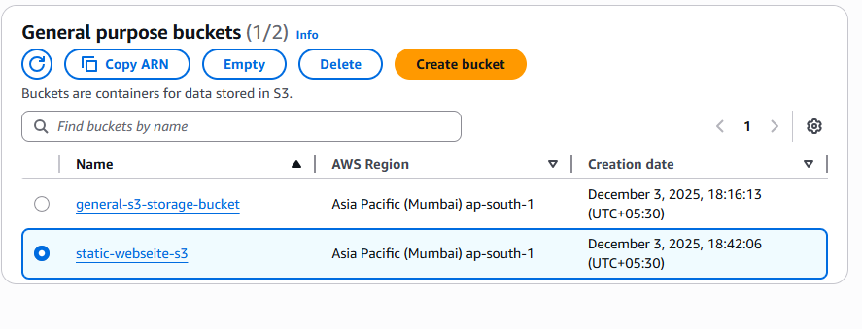
Select your newly created bucket and go to the Properties tab.
Scroll down to the Static website hosting section and click Edit.
Select Enable static website hosting.
In the Index document field, enter your main HTML file name (e.g., index.html).
Click Save changes. This will generate a website endpoint URL (e.g., http://your-bucket-name.s3-website-region.amazonaws.com).

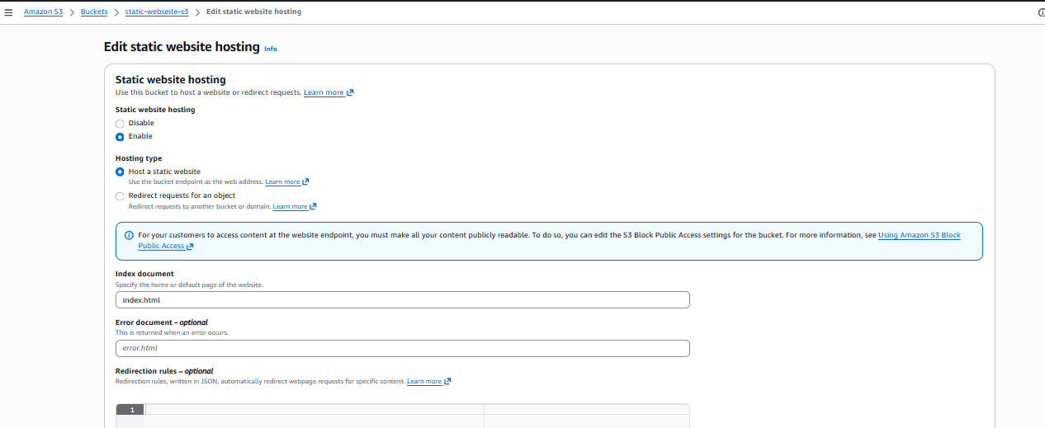
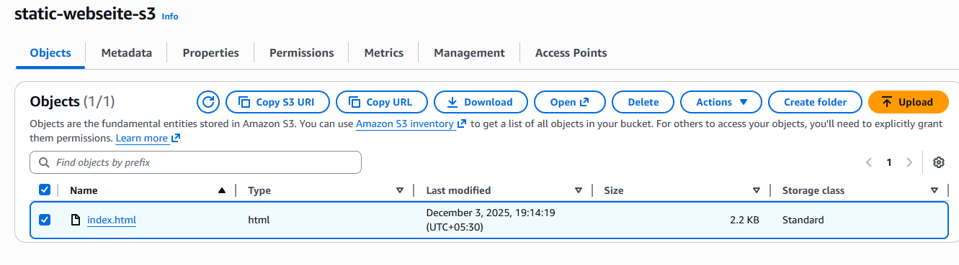

Go actions and make the public using ACL
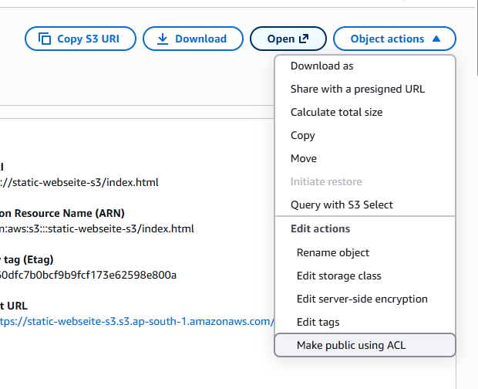
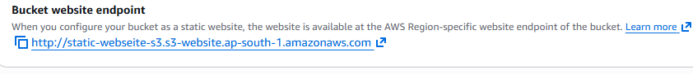

Check the website url in the browser to see the static website.


Enable cross-region replication on S3 buckets.

Existing one s3 bucket in Mumbai region
Created a s3 bucket in Hyderabad region
Under Block Public Access settings for this bucket, uncheck Block all public access to allow public access to your website content.

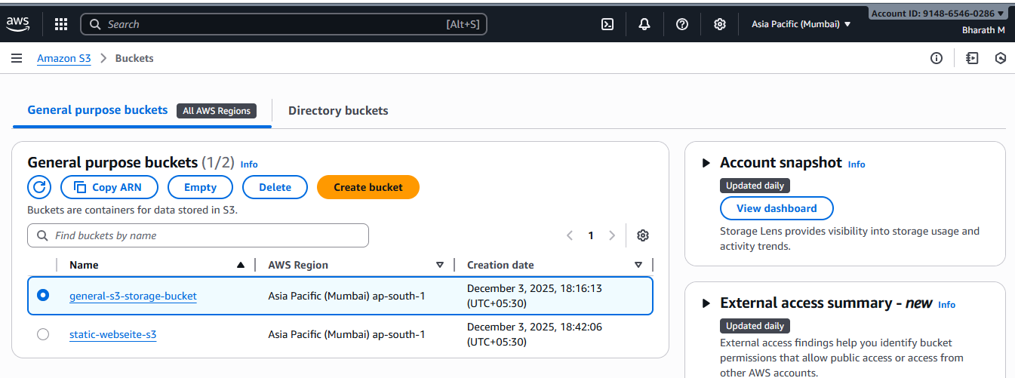
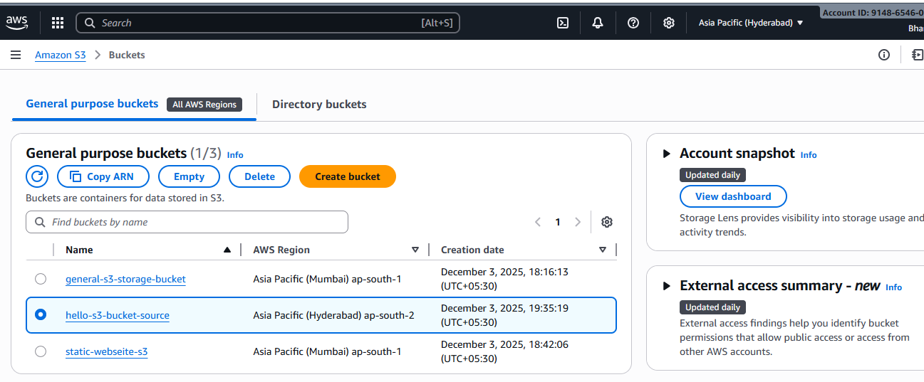

Go to management in Mumbai region to create replication rule
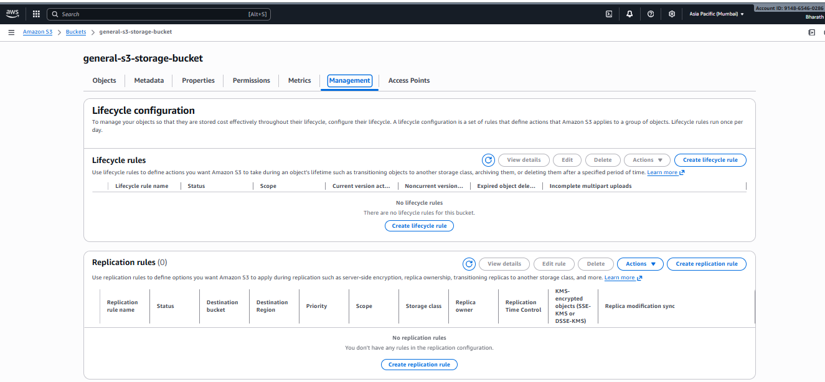

Entre the rule id and set the status as enable
In source bucket choose a rule scope as Apply to all objects in the bucket
Set the destination to Choose a bucket in this account and add the other region bucket name
save the configuration.
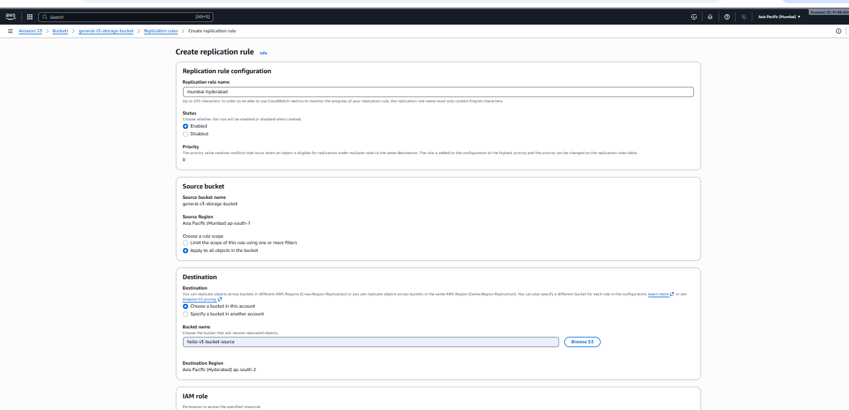
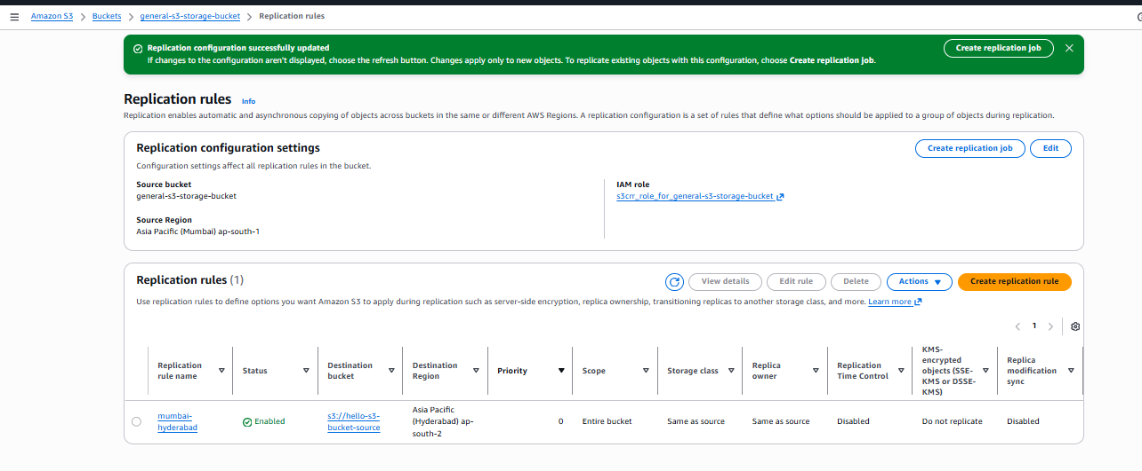

Upload one file in the source region
In objects action make it as public ACL
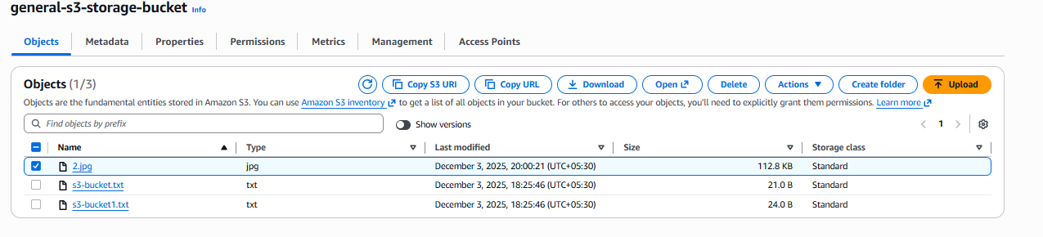
Check in the destination region the file will be replicated.
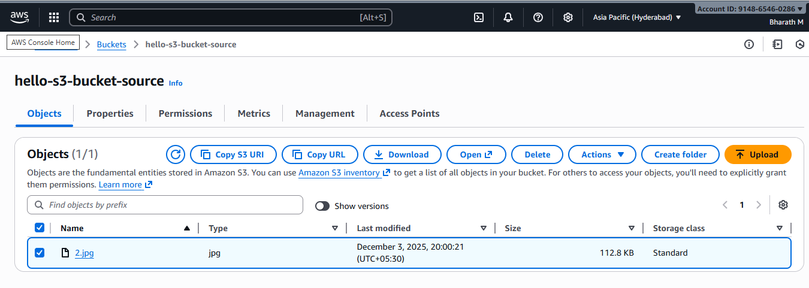

Configure a bucket policy so only the Admin user can see the objects of the S3 bucket.

Go to aws console
Create a s3 bucket

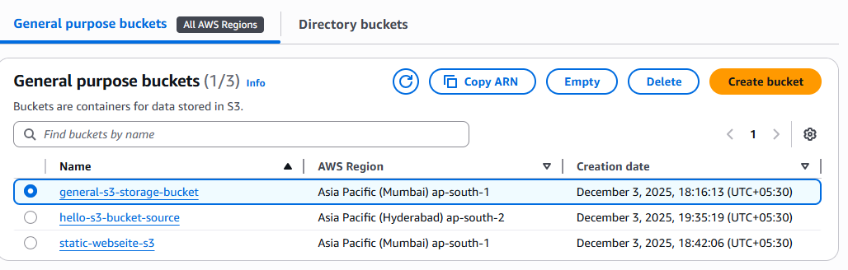

Go to bucket and go to permission in the bucket
Edit the bucket policy with the below code.
{
"Version": "2012-10-17",
"Statement": [
{
"Sid": "AllowRootRead",
"Effect": "Allow",
"Principal": {
"AWS": "arn:aws:iam::<ACCOUNT_ID>:root"
},
"Action": [
"s3:GetObject",
"s3:ListBucket",
"s3:GetBucketLocation"
],
"Resource": [
"arn:aws:s3:::<bucket-name>",
"arn:aws:s3:::<bucket-name>/*"
]
},
{
"Sid": "DenyNonRootRead",
"Effect": "Deny",
"Principal": "*",
"Action": [
"s3:GetObject",
"s3:ListBucket",
"s3:GetBucketLocation"
],
"Resource": [
"arn:aws:s3:::<bucket-name>",
"arn:aws:s3:::<bucket-name>/*"
],
"Condition": {
"ArnNotLike": {
"aws:PrincipalArn": "arn:aws:iam::<ACCOUNT_ID>:root"
}
}
}
]
}

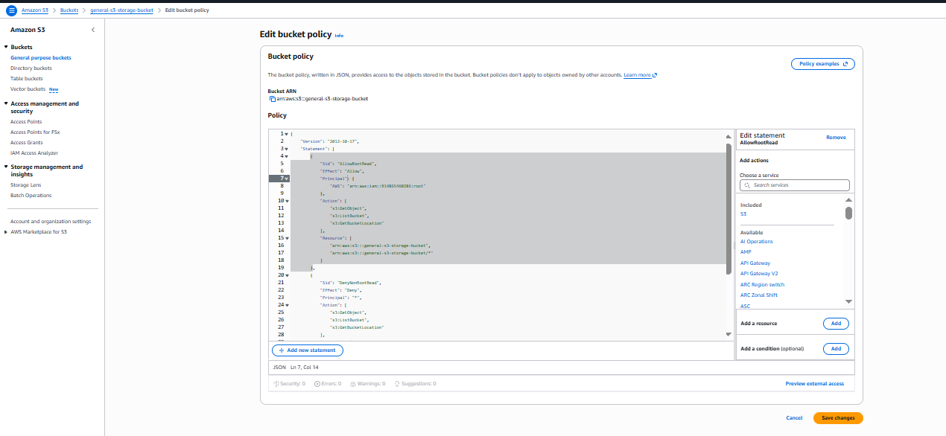
we have 3 objects in the created bucket
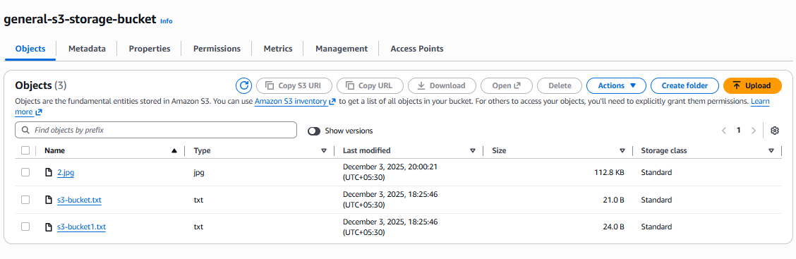

Create one user in IAM and set the permissions to s3fullaccess
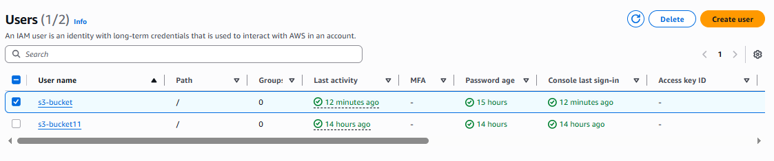

Login to the created user account and check the s3 service.
Created buckets will be available in the user account.

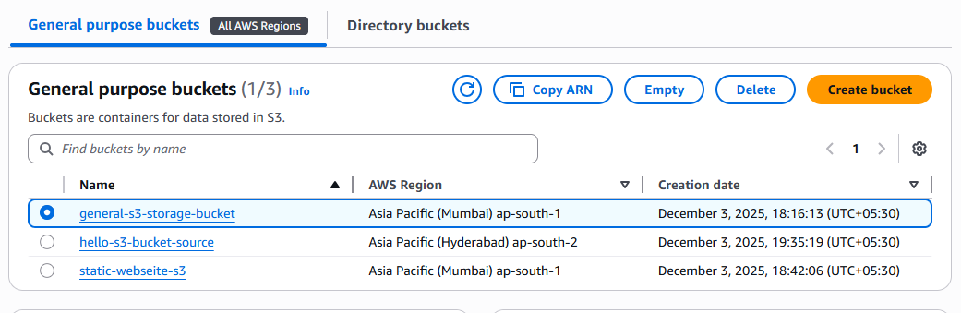

But if we go inside the bucket the objects will not be visible in the user account.
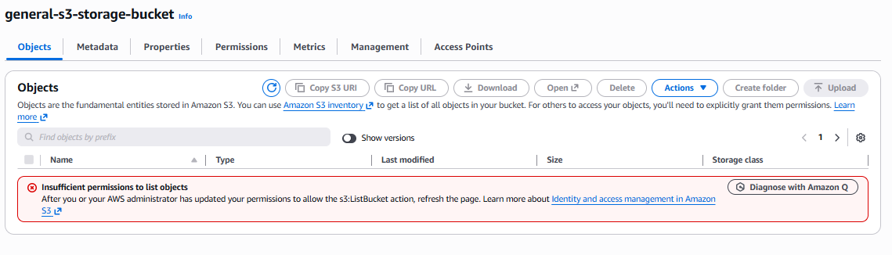

Set up lifecycle policies to automatically transition or delete objects based on specific criteria.

Go to aws console
Go s3 service
Create a bucket and go to bucket
Add some objects in the bucket
To create a lifecycle rules for the bucket, select the bucket and go to permission
Select the lifecycle rules.
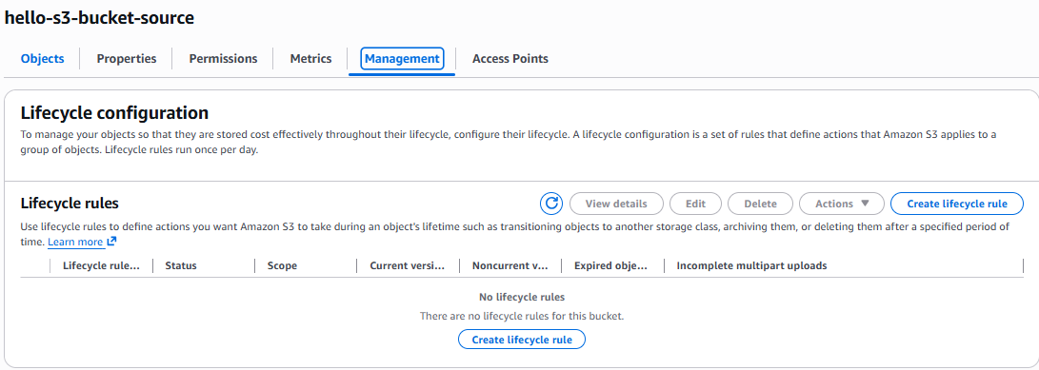
Choose a rule scope -> apply to all objects
Lifecycle rule actions-> Transition current objects to storage classes
Choose your storage classes and the object duration in the transition current versions of
objects between storage classed
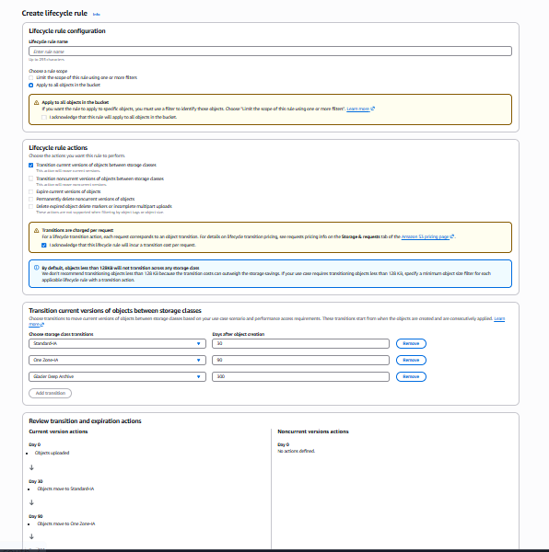

Created a lifecycle configuration
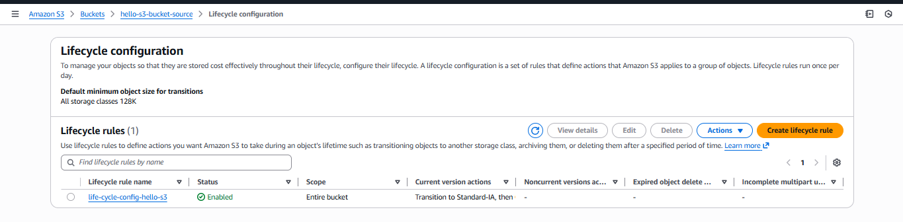

Push some objects to S3 using the AWS CLI.

Connect to the instance
Configure the aws access key and password in the cli
Create sample file using touch command
Push the created file to s3 bucket by using command “aws s3 cp sample.txt s3://(bucket name)”
To check the file moved to bucket or not “aws s3 ls s3://(bucket name)”
We can see sample.txt file in bucket
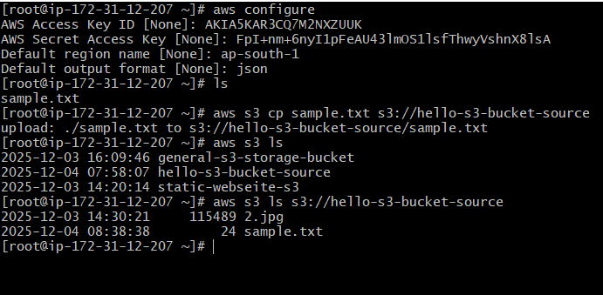

Go to console to check the object has been uploaded to the bucket or not.
We can see the Object uploaded successfully.
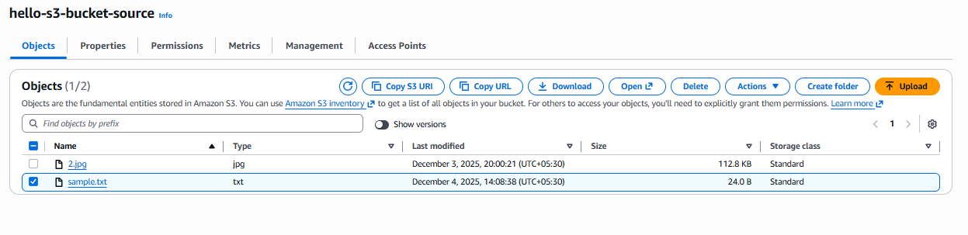

Write a Bash script to create an S3 bucket.

Write a below bash script to create a bucket

BUCKET_NAME="my-bash-s3-bucket-bunny"
REGION="us-east-1 "
aws s3api create-bucket \
--bucket "$BUCKET_NAME" \
--region "$REGION"
echo "Bucket created: $BUCKET_NAME"

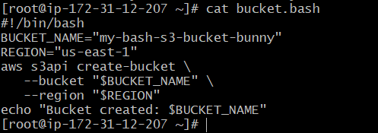
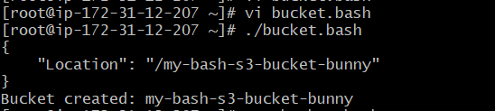
Check in the console whether created bucket has been available or not
In below console bucket has been created.

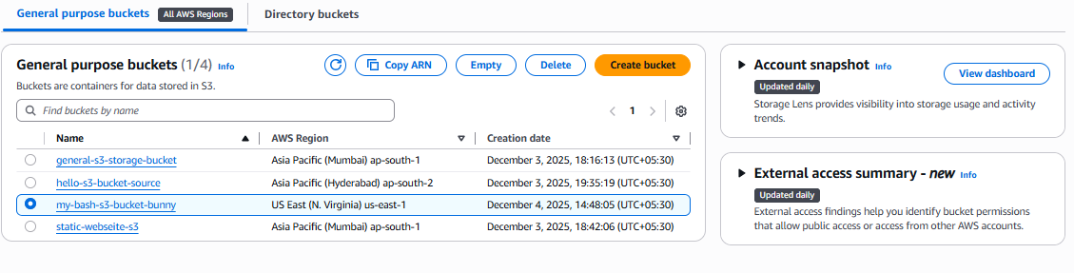

Upload a 1 GB file to S3 using the CLI.
For this task I have generated a file of size 1GB using the command ‘dd if=/dev/zero of=file1gb.bin
bs=1M count=1024’
aws cp file1gb.bin s3:// general-s3-storage-bucket will push the file1gb to the bucket
Check in the console we can see the file 1gb added to the bucket
